A. SOP- Cataloguing & Searching samples in the IFBA Database - Walk Through

We are going to put in a group of samples from 2015, wild salmon grilse, as an example of putting samples away physically and digitally.

Cataloguing samples in the IFBA Database – RS Method (**Physically**)

1. Right now we only have the option add in samples using the RS method. This stands for ‘representative sample’. This method basically means that you can find/collect a bundle of samples (20 envelopes, 50, 100 envelopes, 50 slides - any amount) and if they are all from the same year, species, and location- you can put them in the database and just catalogue 1 sample as it’s representative sample. Then, when people search the database they can find specific years, species and geographic locations. See the ‘B. SOP- Shorthand’ for how find and group, and interpret the shorthand written on samples by Burrishoole scientists throughout the years. Additionally, we will get to how to search the database later on in this SOP.
2. Once you have a bundle of samples, you need to assign one of them a unique archive id (label) and the container a ‘sample set container id’. These are done by accession, see ‘D. SOP Creating and assigning labels’
   1. 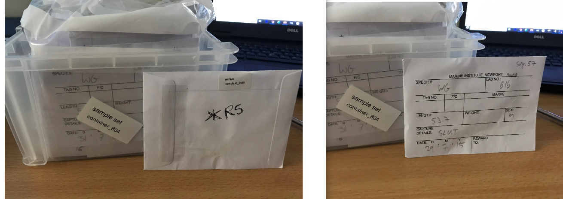
   2. You then put a packet of desiccant in the container. Then you put them away in the a larger, permanent storage unit or cabinet, first digitally then physically. In this case these samples when into **Unit 15.** If the samples in the container have been imaged and those images will be on the SharePoint, then you put those imaged samples in a plastic bag. Sometimes you will have imaged 25 samples, and then the other 25 you haven’t, so you leave them out of the bag. In this case, there are 50 samples here and all have been imaged, so they all went into the bag.

Cataloguing samples in the IFBA Database – RS Method (**Digitally**)

1. First you need to login to the database, which is its own private satellite module in the MI Data Catalogue (<https://data.marine.ie> ). If you want to login to the database, you need to request permission from Data Management Team Leader – Adam Leadbetter. Since Adam is the creator and owner of the catalogue, he is the only one that can administer permission to use it.
   1. Here is the login web page: <https://dmdrupdev01/user/login>
   2. You can also contact Elizabeth Tray ([Elizabeth.tray@marine.ie](mailto:Elizabeth.tray@marine.ie)) and she can give you restricted access and a tutorial on how to use the database.
      1. 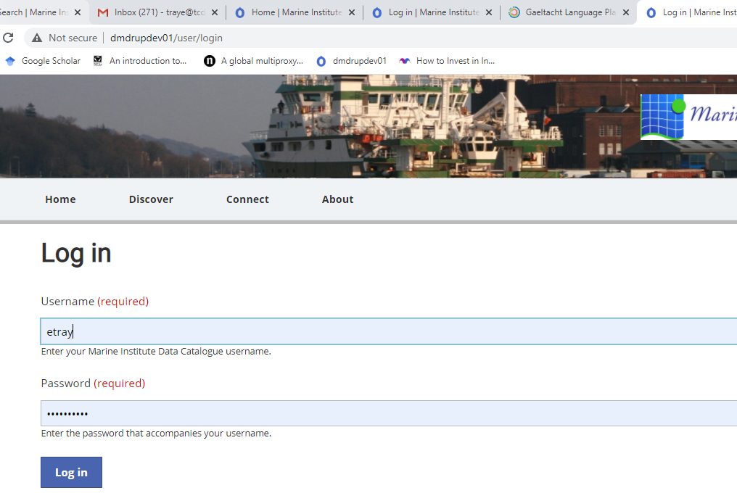
   3. After you login, you get to this page:
      1. 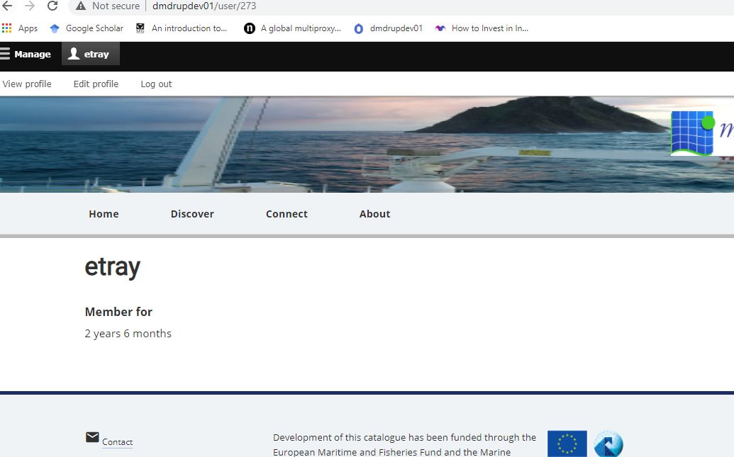
   4. Then you click Manage, and it goes to this page-
      1. 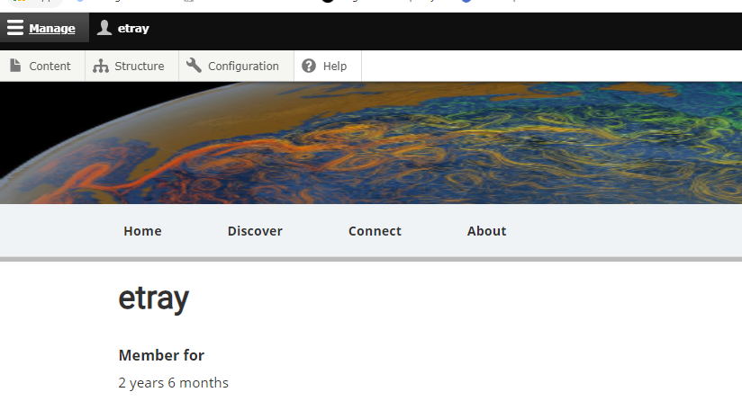
   5. Then you click Content and it brings you to the MAIN page.
   6. Now you have to first make sure you have the following things in order to put a sample set container away
      1. Archive location
      2. Geographic Feature.
      3. We are going to first create a archive location…. So at this main page here you click add content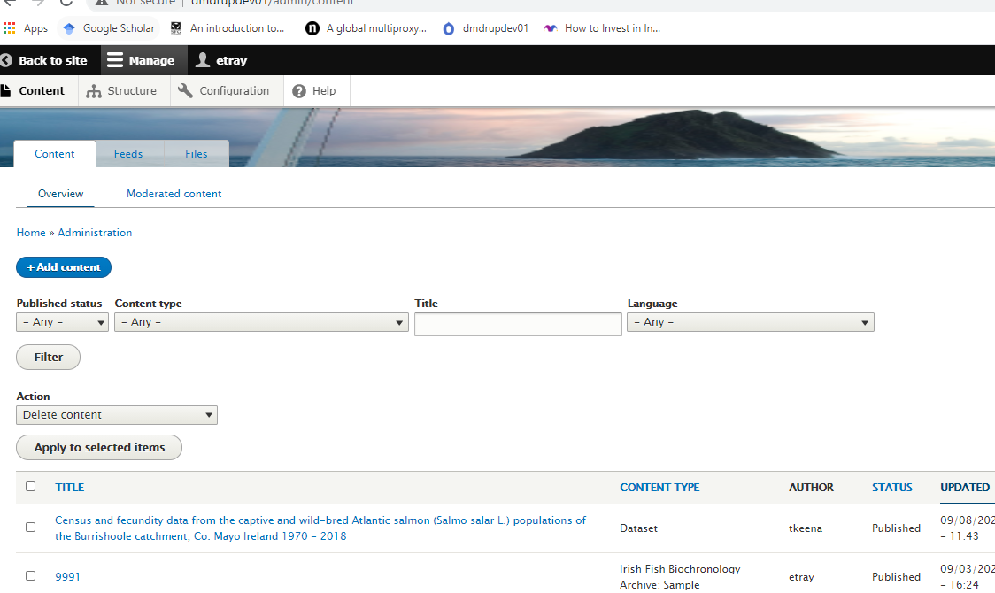
   7. First you create the permeant location. Click Add Archive Location (this is a large unit or cabinet meant for permanent storage) 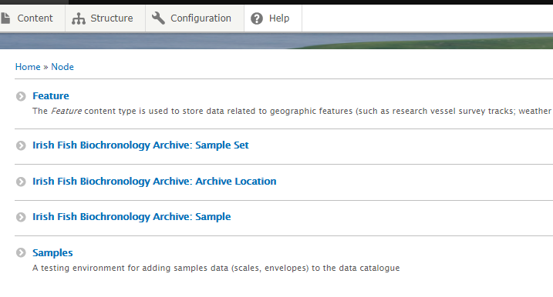
   8. Write in the details for the archive location, it can either be a box or cabinet. The title has to follow the say format as below to make everything clean and uniform and easy to search. I have put in FSA2, which is the fsa2 office and then IFBA and then the unit number. Then click save. It brings you back to the main page.

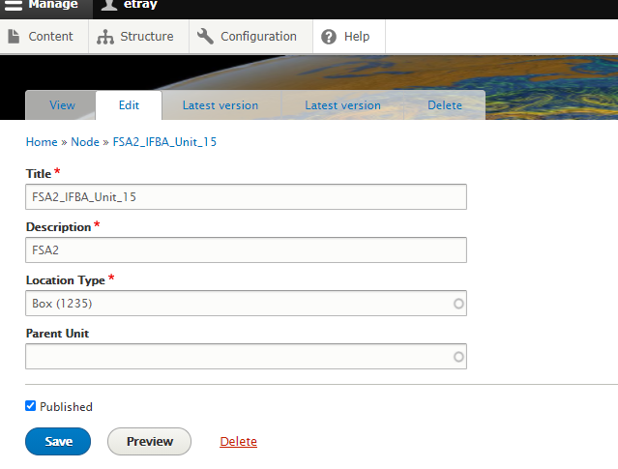

* 1. Here are all of the current ‘permanent storage’ cabinets and units.

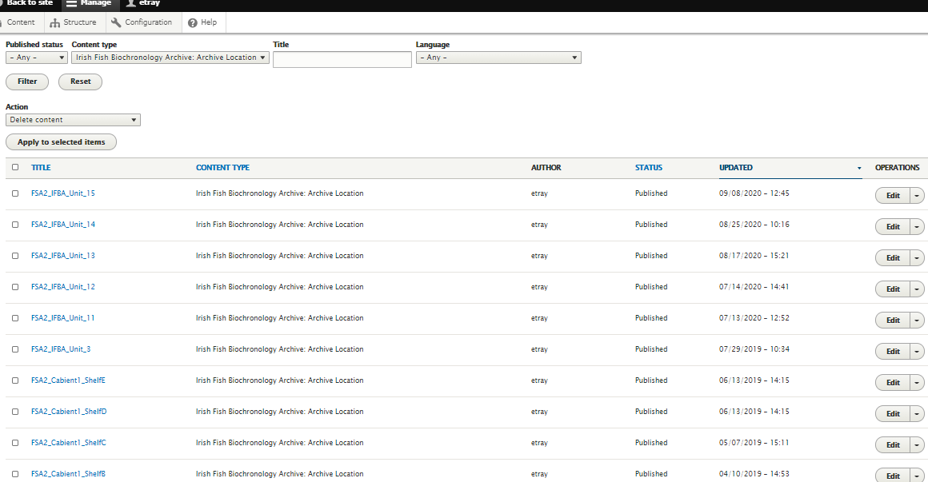

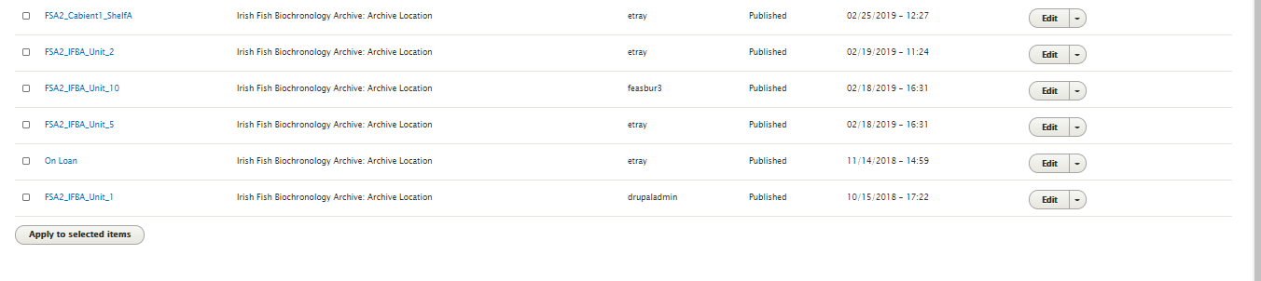

* 1. Here is what they correspond to in reality. On the left these are units with envelope sample set containers, and on the right is Cabinet 1, with slides

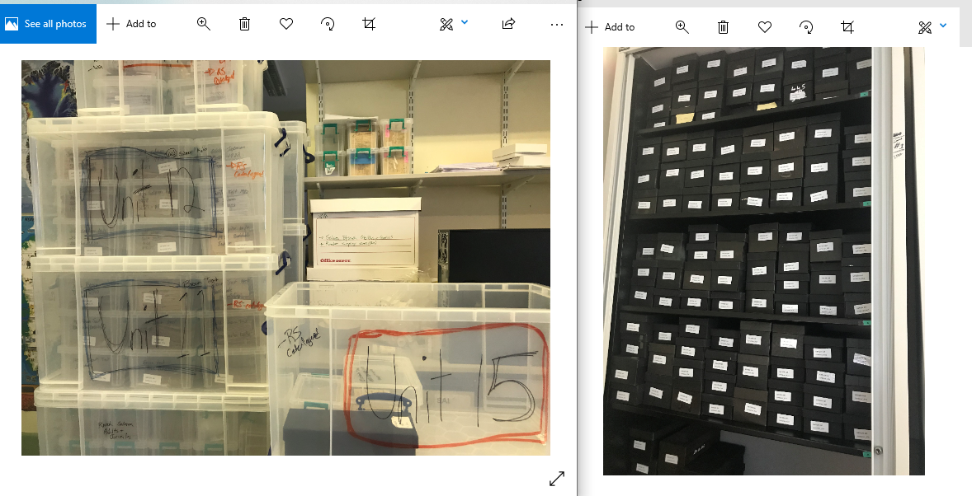

* 1. So after you have a larger permanent archive location, you need to make sure you have a geographic feature. See the ‘C. SOP - Geographic Features for Samples’ in this folder. There is an SOP there on how to create and assign samples a geographic Feature.
  2. Now you can put away the sample set container. You go back to main page and click add content
  3. Now click Irish Fish Biochronology Archive: Sample Set

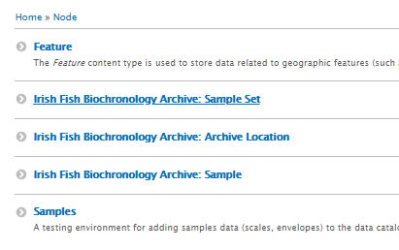

* 1. Now you create your sample set, see below. It’s best to follow another sample set as an example.
  2. See PPT file- Creating Sample Set_Screen Record Video (This is an SOP video recording)
  3. See PPT file- Creating RS Sample_Screen Record Video (This is an SOP video recording)

Searching samples in the IFBA Database

1. Searching Front End
   1. If you want to search what is in the database, at the front end use this link:
      1. <http://dmdrupdev01/ifba-search?f%5B0%5D=species%3A1373>
2. Searching Back End
   1. You can search in the text box of the home page of the catalogue.
      1. <http://dmdrupdev01/ifba-search?f%5B0%5D=species%3A1373>
3. See PPT file- Searching Samples in IFBA_Screen Record Video (This is an SOP video recording)